10. Write a C program to implement Linked list operations

**Aim:**To write a C program to implement linked list operations such as **insertion, deletion, traversal (display)**.

**Algorithm**

1. **Start the program.**
2. **Define a struct Node with data and a pointer to the next node.**
3. **Initialize head = NULL.**
4. **Define functions for:**
   * **Insert at end:**
     + **Create a new node.**
     + **If list is empty, make new node as head.**
     + **Else, traverse till last node and link new node.**
   * **Delete a node:**
     + **If list is empty, print "List is empty".**
     + **Else, traverse to find the node.**
     + **Adjust links and free memory.**
   * **Display:**
     + **Traverse from head to end.**
     + **Print data of each node.**
5. **Create a menu-driven program:**
   * + **Insert**
     1. **Delete**
     2. **Display**
     3. **Exit**
6. **Perform operations until the user exits.**
7. **Stop.**

**Program**

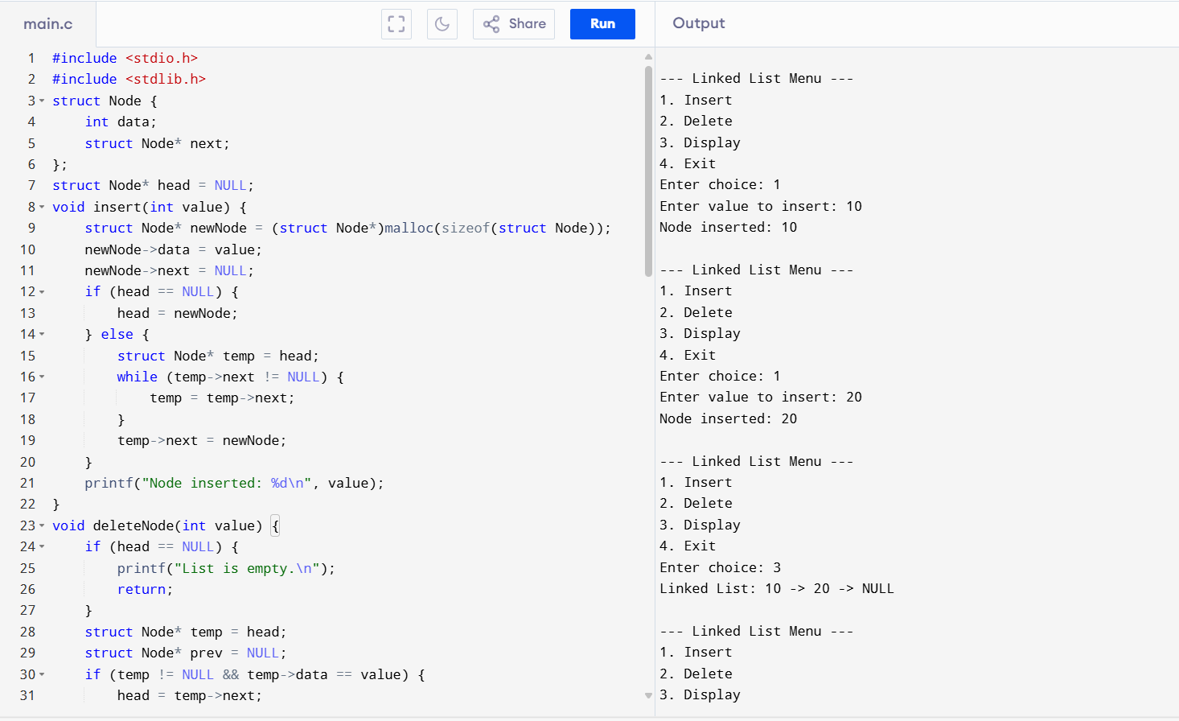

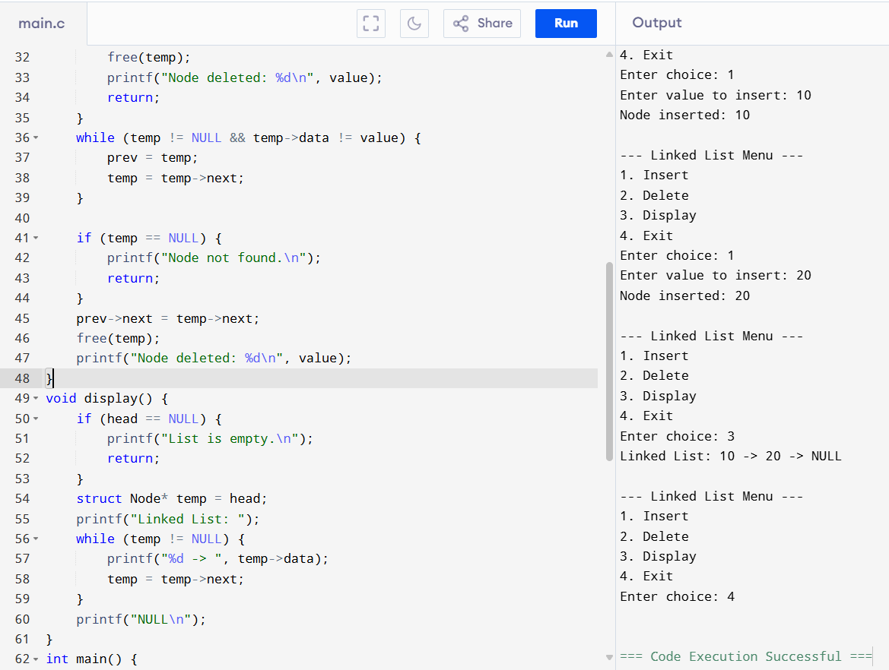

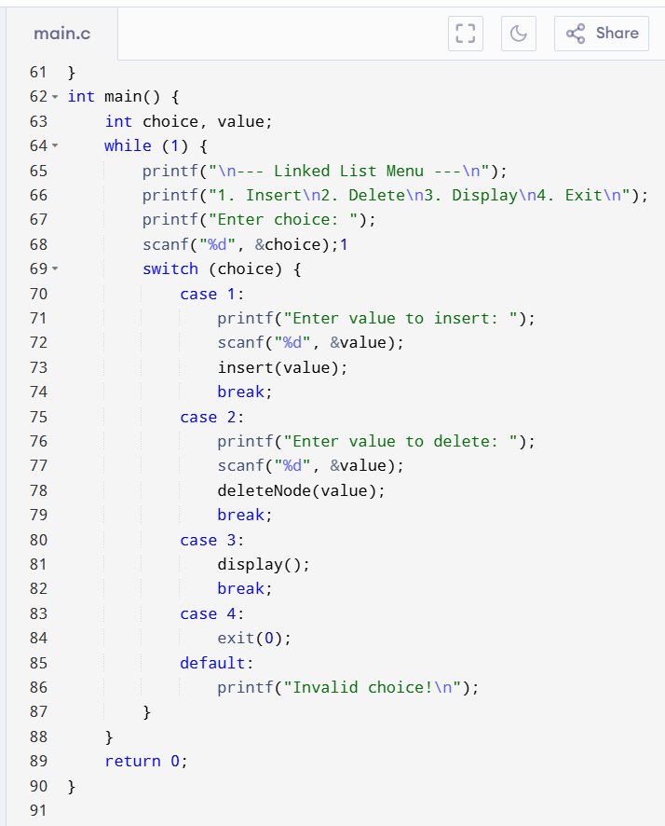

**Result:**The program successfully implements linked list operations (insert, delete, display) using C.